**Assignment 4th , Day 8**

**Assignment 0**

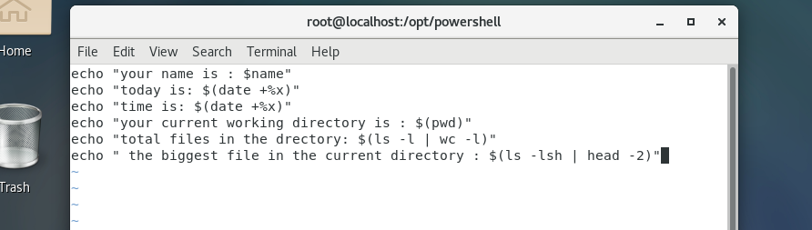

**Assignment 1**

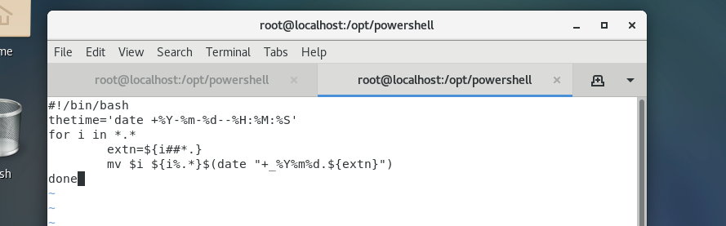

**Assignment 2**

